Q1:

Q2:

Q3:

Q4:

Q5:  
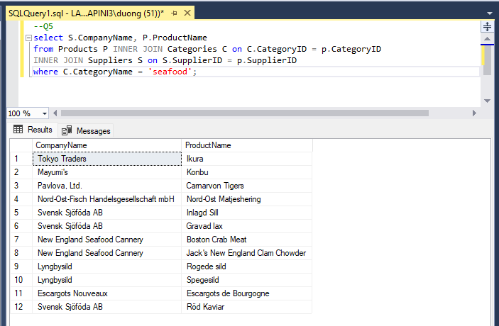

Q6:

